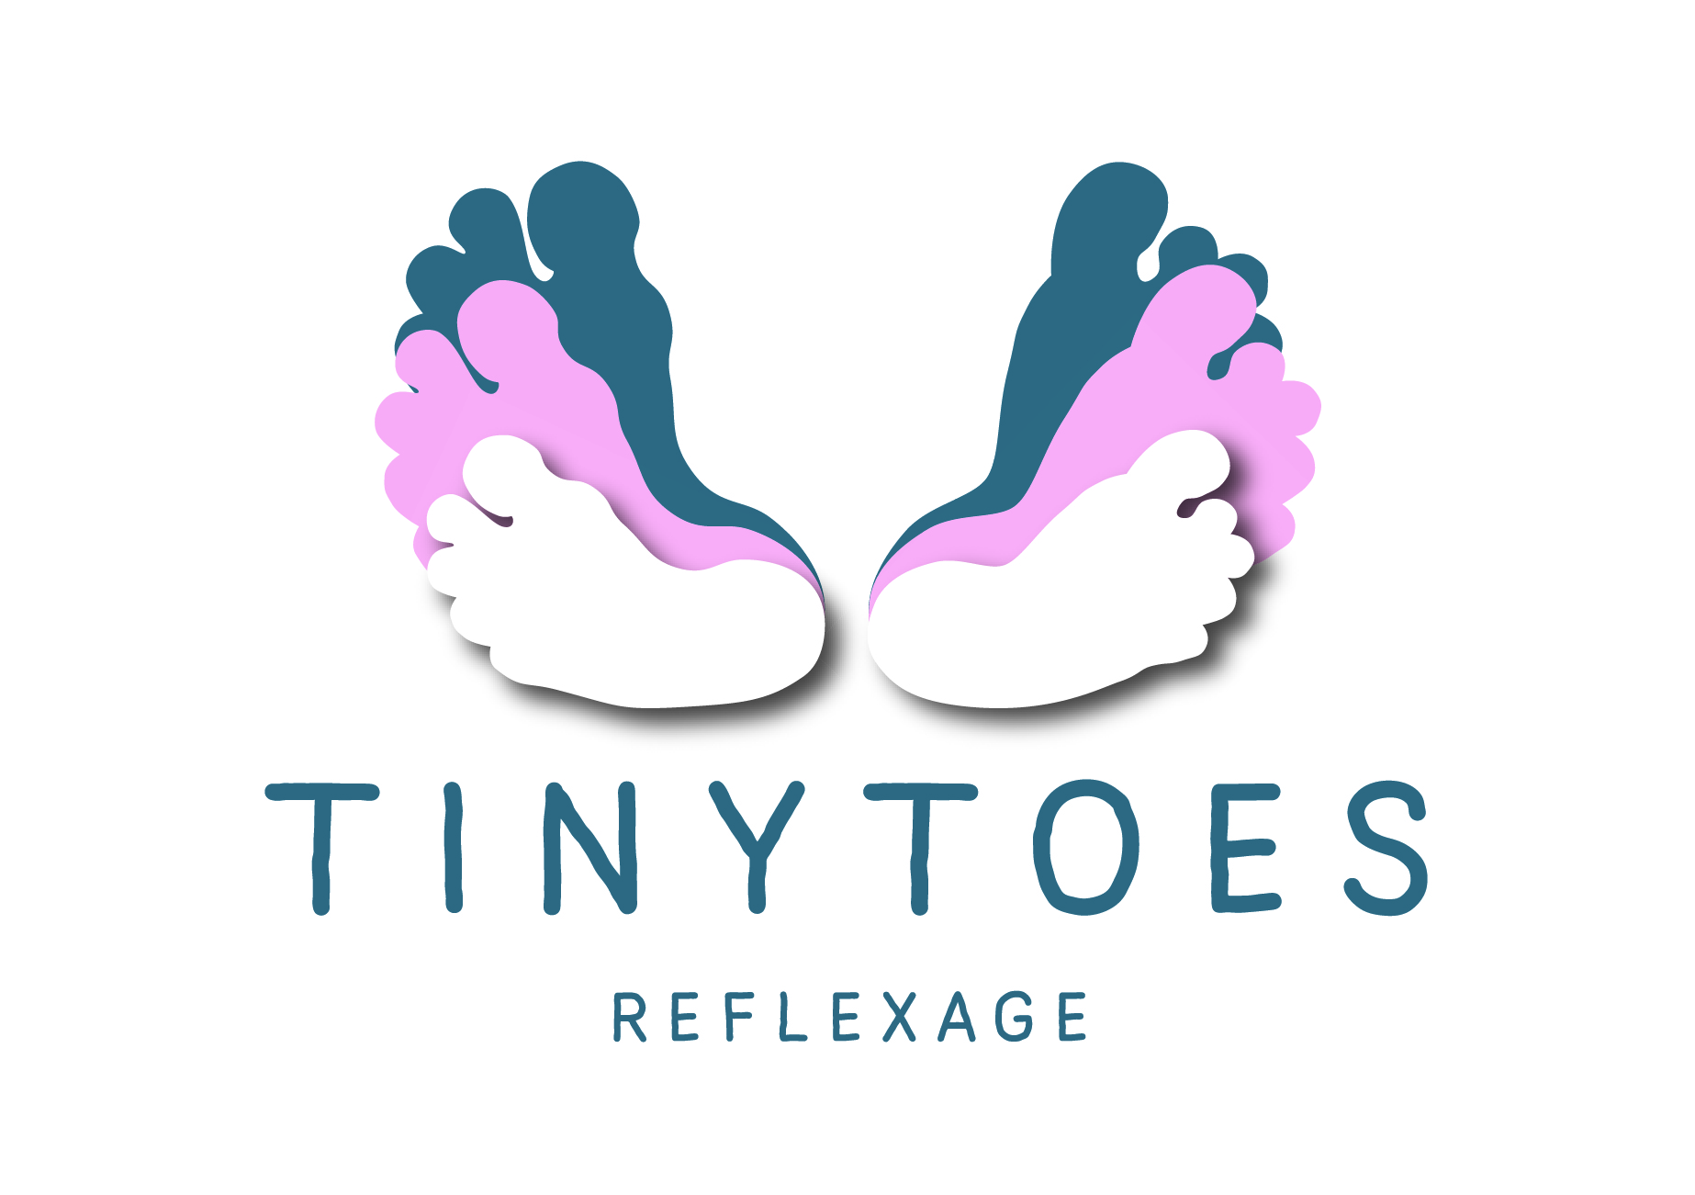

Tiny Toes Reflexage Instructor CPD course

Distance learning

Approved course by PR & AOR

Affiliated with Three Shires School of Reflexology

Date:

Forename:

Surname:

Occupation:

Address

Postcode:

Telephone

Email:

I declare that I have read, understood and agree to abide by the booking conditions and have paid £320 (British Pounds) (please indicate amount with an X).

I will print and sign the agreement form

Signed:
Date:

Terms and Conditions of Booking
All participants must hold a reflexology practitioner qualification, relevant insurance and be aged 18 or over. A booking is only accepted on receipt of a completed and signed booking form with the appropriate payment.
The course must be completed within 6 months. No refunds are available for any uncompleted course.

BACS Details

Tiny Toes Reflexage

Sort code: 30-99-50

Account Number: 18050060

PayPal

tinytoesreflexage@aol.com

