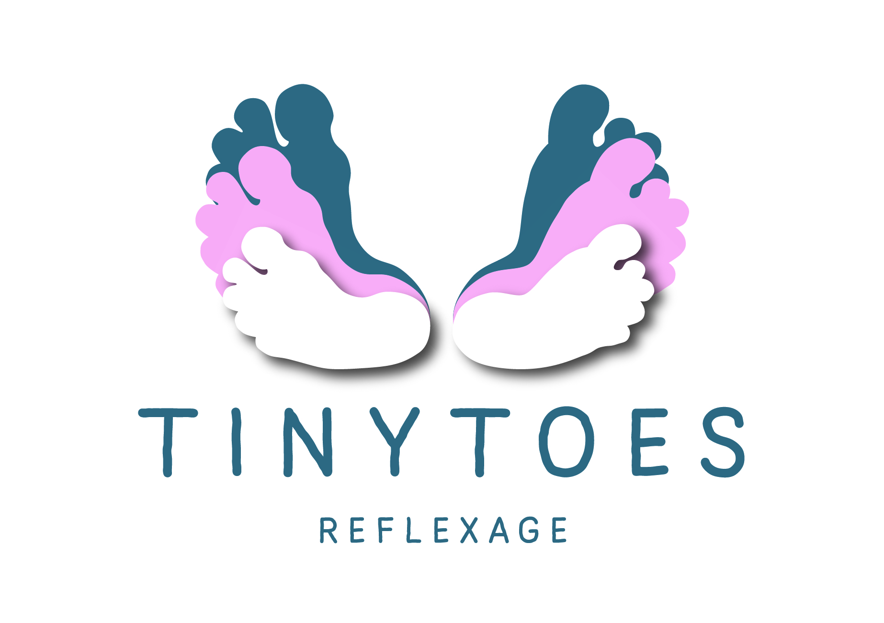

Tiny Toes Reflexage instructor CPD course

Approved by PR Reflexology

Hosted by Emma Baxter PRM

Date:

Venue – Lavender Room Reflexology, 14 Low Greeve, Wootton, Northampton, NN4 6BD

Forename:

Surname:

Occupation:

Address

Postcode:

Telephone

Email:

I declare that I have read, understood and agree to abide by the booking conditions and have paid (please indicate amount with an X)

Deposit £100

Full payment £275

Signed:
Date:

Terms and Conditions of Booking
All participants must hold a reflexology practitioner qualification, relevant insurance and be aged 18 or over. A booking is only accepted on receipt of a completed and signed booking form with the appropriate payment. Balance of payment must be received 30 days prior to course commencement at which point pre-course information will be sent. Should you cancel your booking less than 14 days before the course commences the full amount will be payable. The deposit is non-refundable

BACS Details

Emma Baxter

Sort code: 30-15-53

Account Number 00138377

